**K8S Security Context & Admission Controllers**

Security Context

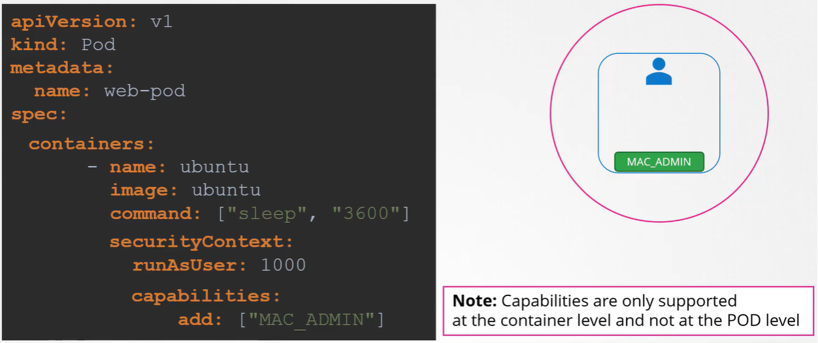

Admission Controllers

RBAC(Role based access control) Restriction

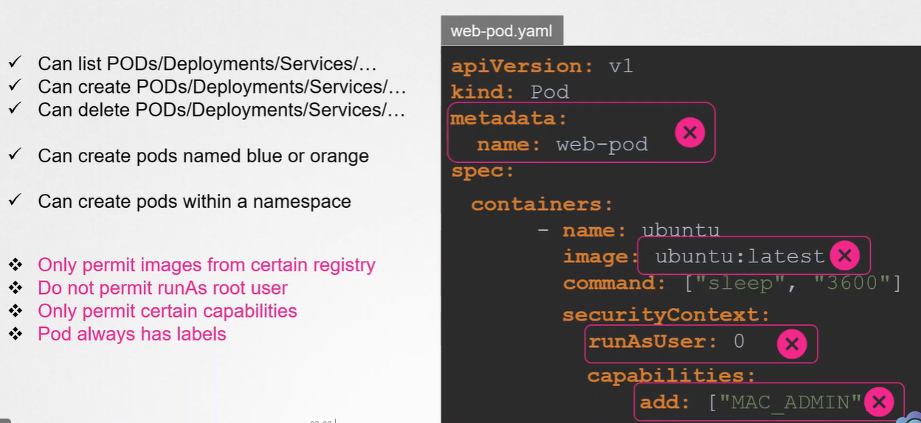

Therefore, we need admission controllers

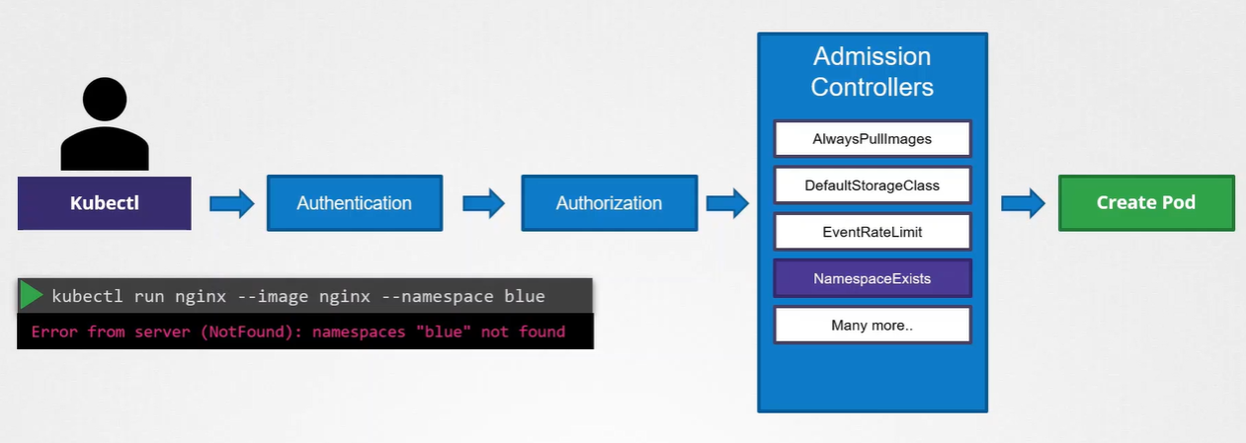

View enabled admission controllers

kube-apiserver –h | grep enable-admission-plugins

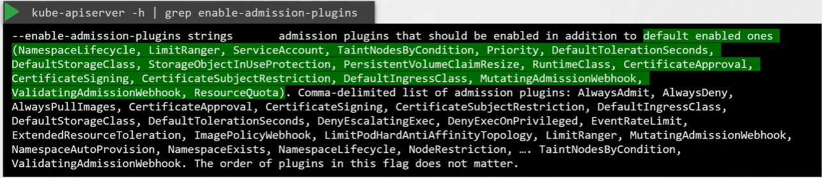

Enable & Disable Admission Controllers

